Practical No: 11
Name:- Danish Altaf Solkar Enrolment No:- 24111590805
Class:- CO3KB Subject:- CGR
Aim :- WAP for 3D Rotation
Program :-
#include <stdio.h>
#include <conio.h>
#include <math.h>
#include <graphics.h>
int x1, x2, y1, y2, mx, my, depth;
void draw();
void rotate();
void main() {
int gd = DETECT, gm;
initgraph(&gd, &gm, "C:\\TURBOC3\\BGI");
printf("\n 3D Transformation Rotation \n\n");
printf("\n Enter 1st top value (x1,y1):");
scanf("%d%d", &x1, &y1);
printf("\n Enter right bottom value (x2,y2):");
scanf("%d%d", &x2, &y2);
depth = (x2 - x1) / 4;
mx = (x1 + x2) / 2;
my = (y1 + y2) / 2;
draw();
getch();
cleardevice();
rotate();
getch();
closegraph();
}
void draw() {
bar3d(x1, y1, x2, y2, depth, 50);
}
void rotate() {
float t;
int a1, b1, a2, b2, dep;
printf("Enter the angle to rotate (in degrees): ");
scanf("%f", &t);
t = t * (3.14 / 180); // Convert angle to radians
a1 = mx + (x1 - mx) * cos(t) - (y1 - my) * sin(t);
a2 = mx + (x2 - mx) * cos(t) - (y2 - my) * sin(t);
b1 = my + (x1 - mx) * sin(t) + (y1 - my) * cos(t);
b2 = my + (x2 - mx) * sin(t) + (y2 - my) * cos(t);
if (a2 > a1)
dep = (a2 - a1) / 4;
else
dep = (a1 - a2) / 4;
bar3d(a1, b1, a2, b2, dep, 1);
setcolor(9);
}
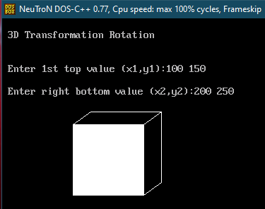
OUTPUT :-

